**Ex. No. : 01 Date:**

**Register No. : 221701501 Name : Naveen raj B**



**GUI Components**

**Aim**

Develop an application to change the font and color of the text and display a toast message when the user presses the button.

***Procedure:***

**Step 1 :** File → New Project  
 Provide the application name and click “Next”.

**Step 2 :** Select the target Android devices  
 Select the minimum SDK to run the application. Click “Next”.

**Step 3 :** Choose the activity for the application  
 By default, choose “Blank Activity”. Click “Next”.

**Step 4 :** Enter activity name and click “Finish”.

**Step 5 :** Edit the program  
 Design the UI in activity_main.xml and write Kotlin code in

MainActivity.kt

**Step 6 :** Run the application  
 Two ways to run the application:

1. Running through emulator
2. Running through mobile device

***AndroidManifest.xml***

**<?xml version="1.0" encoding="utf-8"?>**

**<manifest xmlns:android="http://schemas.android.com/apk/res/android"**

**xmlns:tools="http://schemas.android.com/tools">**

**<application**

**android:allowBackup="true"**

**android:dataExtractionRules="@xml/data_extraction_rules"**

**android:fullBackupContent="@xml/backup_rules"**

**android:icon="@mipmap/ic_launcher"**

**android:label="@string/app_name"**

**android:roundIcon="@mipmap/ic_launcher_round"**

**android:supportsRtl="true"**

**android:theme="@style/Theme.GUI"**

**tools:targetApi="31">**

**<activity**

**android:name=".MainActivity"**

**android:exported="true">**

**<intent-filter>**

**<action android:name="android.intent.action.MAIN" />**

**<category android:name="android.intent.category.LAUNCHER" />**

**</intent-filter>**

**</activity>**

**</application>**

**</manifest>**

***Activity_main.xml***

**<?xml version="1.0" encoding="utf-8"?>**

**<LinearLayout xmlns:android="http://schemas.android.com/apk/res/android"**

**xmlns:tools="http://schemas.android.com/tools"**

**android:id="@+id/rootLayout"**

**android:layout_width="match_parent"**

**android:layout_height="match_parent"**

**android:orientation="vertical"**

**android:padding="16dp"**

**android:background="#6200EA"**

**tools:context=".MainActivity">**

**<TextView**

**android:id="@+id/appTitleTextView"**

**android:layout_width="match_parent"**

**android:layout_height="wrap_content"**

**android:text="Text Customization"**

**android:textSize="24sp"**

**android:textColor="#FFFFFF"**

**android:textStyle="bold"**

**android:gravity="center"**

**android:layout_marginBottom="32dp"/>**

**<TextView**

**android:id="@+id/collegeNameTextView"**

**android:layout_width="match_parent"**

**android:layout_height="wrap_content"**

**android:text="Rajalakshmi Engineering College"**

**android:textSize="20sp"**

**android:textColor="#FFFFFF"**

**android:gravity="center"**

**android:padding="16dp"**

**android:layout_marginBottom="32dp"/>**

**<Button**

**android:id="@+id/changeFontSizeButton"**

**android:layout_width="match_parent"**

**android:layout_height="wrap_content"**

**android:text="Change Font Size"**

**android:layout_marginBottom="16dp"**

**android:backgroundTint="#8A2BE2"/>**

**<Button**

**android:id="@+id/changeFontColorButton"**

**android:layout_width="match_parent"**

**android:layout_height="wrap_content"**

**android:text="Change Font Color"**

**android:layout_marginBottom="16dp"**

**android:backgroundTint="#8A2BE2"/>**

**<Button**

**android:id="@+id/changeBackgroundButton"**

**android:layout_width="match_parent"**

**android:layout_height="wrap_content"**

**android:text="Change Background Color"**

**android:layout_marginBottom="16dp"**

**android:backgroundTint="#8A2BE2"/>**

**</LinearLayout>**

***MainActivity.kt***

**package com.example.gui**

**import android.graphics.Color**

**import android.graphics.Typeface**

**import android.os.Bundle**

**import android.view.View**

**import android.widget.Button**

**import android.widget.TextView**

**import android.widget.Toast**

**import android.appcompat.app.AppCompatActivity**

**class MainActivity : AppCompatActivity() {**

**private lateinit var collegeNameTextView: TextView**

**override fun onCreate(savedInstanceState: Bundle?) {**

**super.onCreate(savedInstanceState)**

**setContentView(R.layout.activity_main)**

**collegeNameTextView = findViewById(R.id.collegeNameTextView)**

**// Set initial values**

**collegeNameTextView.text = "Rajalakshmi Engineering College"**

**// Setup buttons**

**setupChangeFontSizeButton()**

**setupChangeFontColorButton()**

**setupChangeBackgroundColorButton()**

**}**

**private fun setupChangeFontSizeButton() {**

**val button = findViewById<Button>(R.id.changeFontSizeButton)**

**val fontSizes = arrayOf(16f, 20f, 24f, 28f, 32f)**

**var currentIndex = 0**

**button.setOnClickListener {**

**currentIndex = (currentIndex + 1) % fontSizes.size**

**collegeNameTextView.textSize = fontSizes[currentIndex]**

**showToast("Font size changed to ${fontSizes[currentIndex]}sp")**

**}**

**}**

**private fun setupChangeFontColorButton() {**

**val button = findViewById<Button>(R.id.changeFontColorButton)**

**val colors = arrayOf(**

**Color.BLACK,**

**Color.RED,**

**Color.BLUE,**

**Color.GREEN,**

**Color.MAGENTA**

**)**

**val colorNames = arrayOf("Black", "Red", "Blue", "Green", "Magenta")**

**var currentIndex = 0**

**button.setOnClickListener {**

**currentIndex = (currentIndex + 1) % colors.size**

**collegeNameTextView.setTextColor(colors[currentIndex])**

**showToast("Text color changed to ${colorNames[currentIndex]}")**

**}**

**}**

**private fun setupChangeBackgroundColorButton() {**

**val button = findViewById<Button>(R.id.changeBackgroundButton)**

**val colors = arrayOf(**

**Color.WHITE,**

**Color.LTGRAY,**

**Color.CYAN,**

**Color.YELLOW,**

**Color.parseColor("#3F51B5") // Indigo**

**)**

**val colorNames = arrayOf("White", "Light Gray", "Cyan", "Yellow", "Indigo")**

**var currentIndex = 0**

**// Get the root layout**

**val rootLayout = findViewById<View>(R.id.rootLayout)**

**button.setOnClickListener {**

**currentIndex = (currentIndex + 1) % colors.size**

**// Change the background color of the entire layout**

**rootLayout.setBackgroundColor(colors[currentIndex])**

**// Change text colors to ensure readability**

**if (colors[currentIndex] == Color.YELLOW || colors[currentIndex] == Color.WHITE || colors[currentIndex] == Color.LTGRAY) {**

**collegeNameTextView.setTextColor(Color.BLACK)**

**findViewById<TextView>(R.id.appTitleTextView).setTextColor(Color.BLACK)**

**} else {**

**collegeNameTextView.setTextColor(Color.WHITE)**

**findViewById<TextView>(R.id.appTitleTextView).setTextColor(Color.WHITE)**

**}**

**showToast("Background changed to ${colorNames[currentIndex]}")**

**}**

**}**

**private fun showToast(message: String) {**

**Toast.makeText(this, message, Toast.LENGTH_SHORT).show()**

**}**

**}**

***Output***

**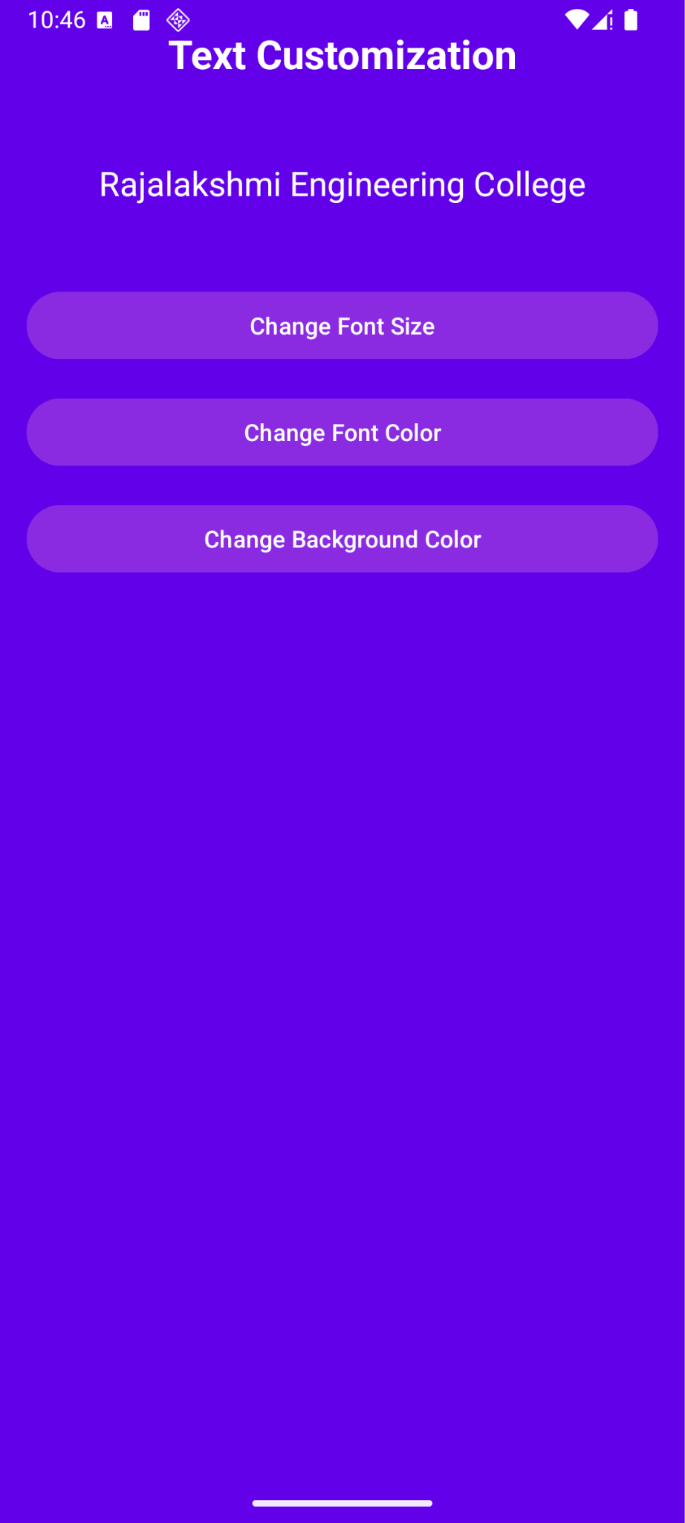 *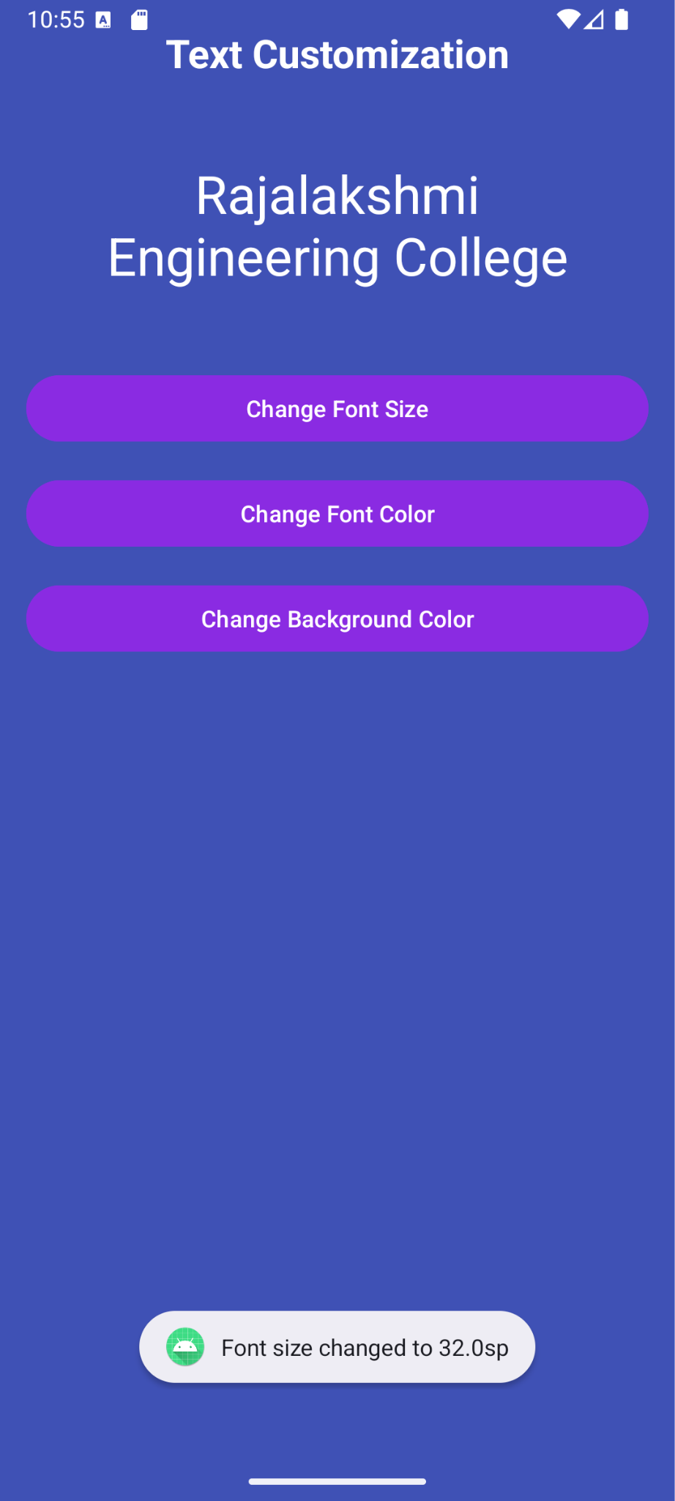***

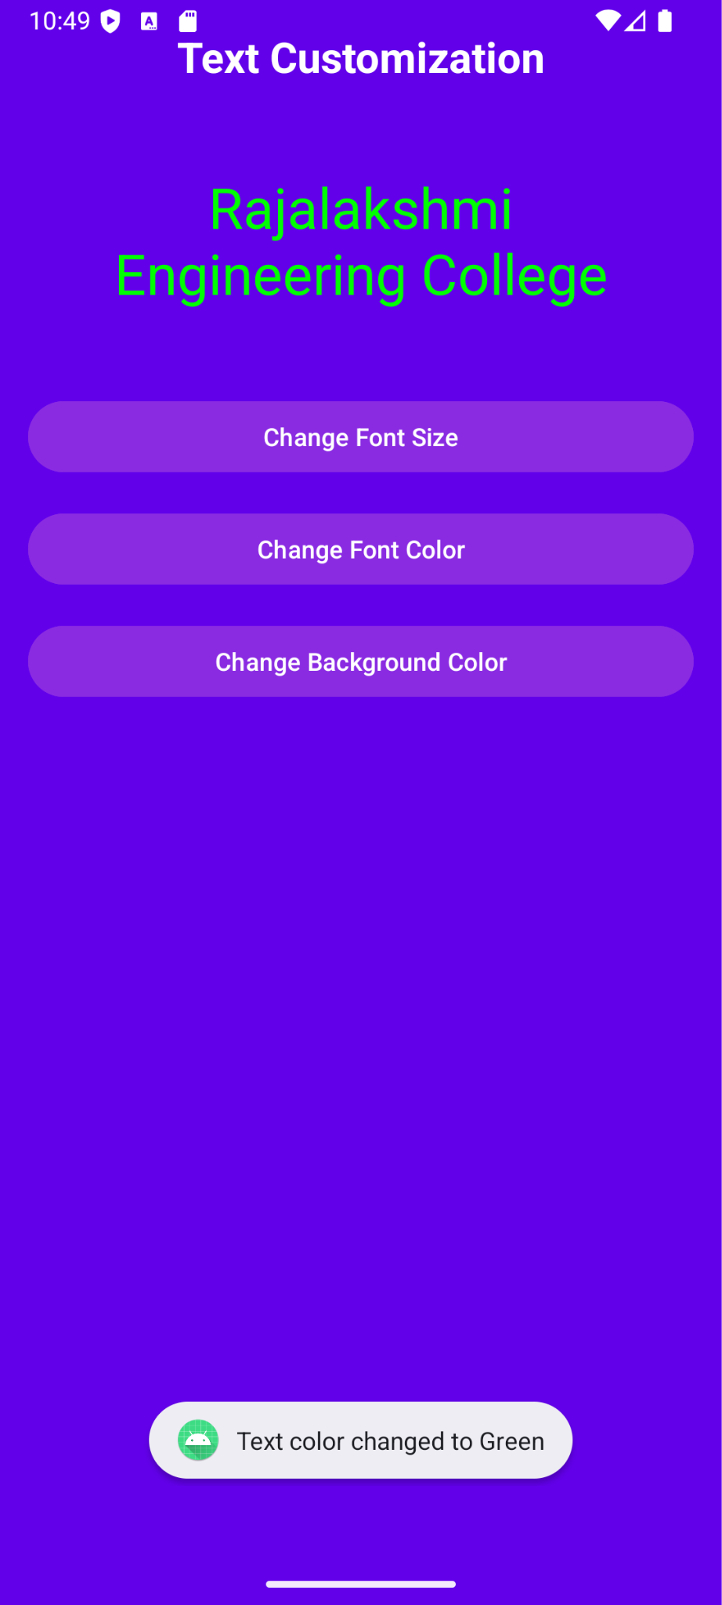 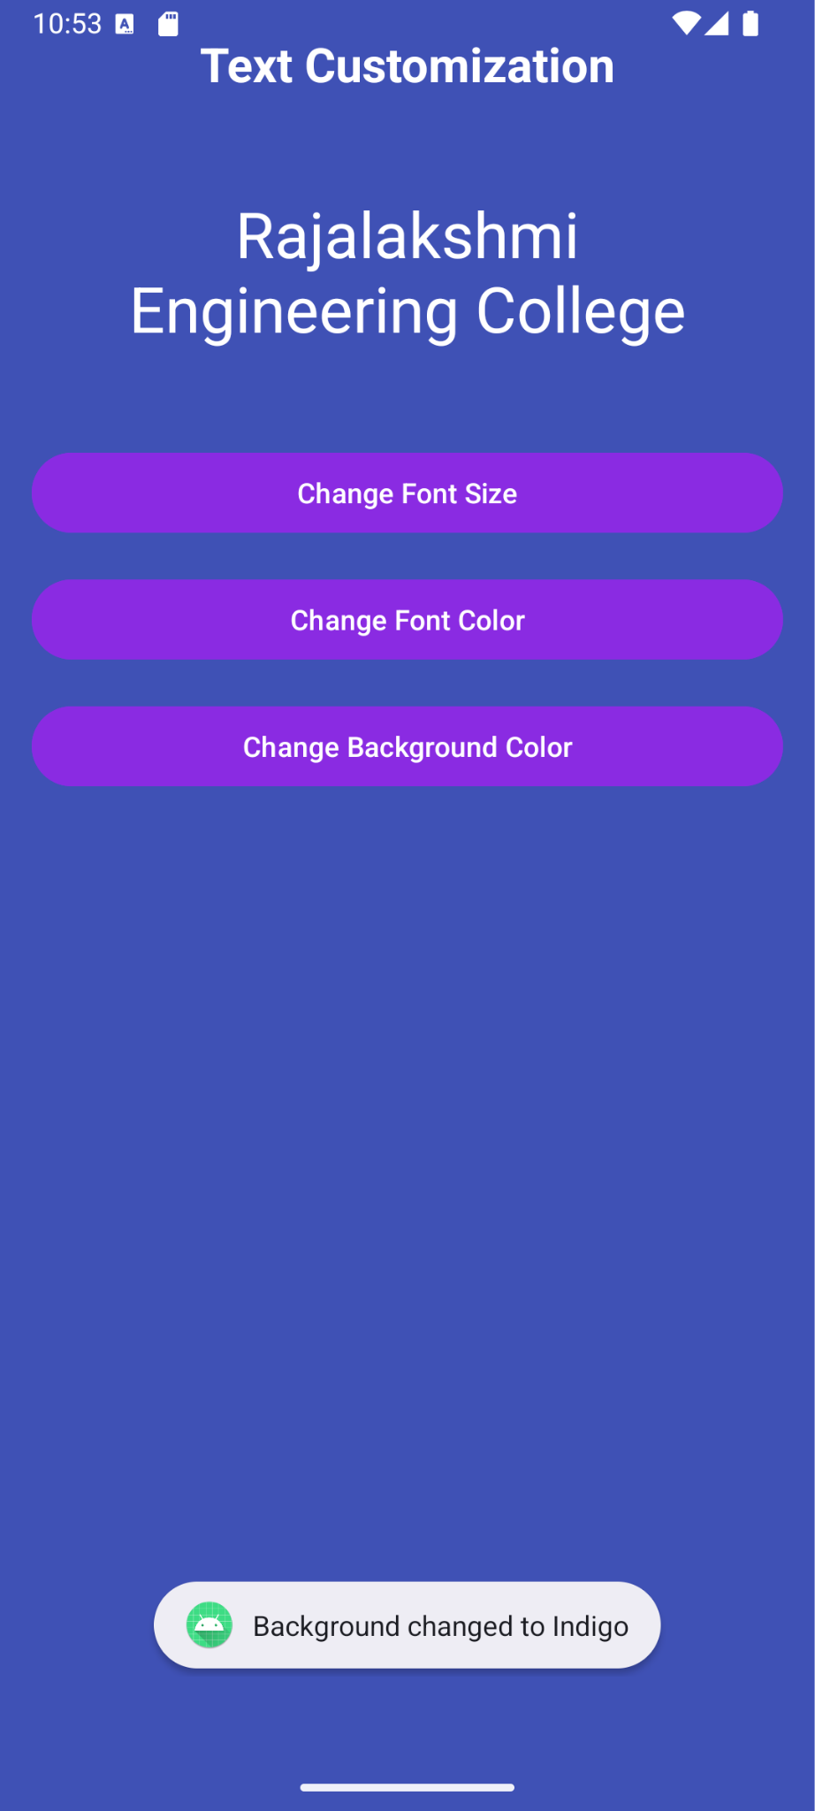

**Result:**

The GUI application successfully displays a user interface and performs the intended functions when run on an emulator or mobile device.